Simulated Production Incident Report & RCA
Task: Buggy Application Failure – Minikube Kubernetes Cluster
Date: 20 Nov 2025
Environment: Minikube (Docker driver), Kubernetes, Python Flask app

📌 1. Incident Summary
A Python Flask-based microservice deployed in a Kubernetes Minikube environment exhibited intermittent crashes, HTTP 500 errors, and timeouts under load. The issue was reproduced consistently, logs were captured, and a full Root Cause Analysis (RCA) was performed.
This simulation replicates a real-world production incident, helping demonstrate application debugging, observability, and issue analysis.

📌 2. Impact Assessment
Impact Area | Details
Application Availability | 15–30% of requests failed randomly
User Experience | Some requests timed out or returned errors
Service Stability | Backend became unstable under repeated access
Pods | Remained in "Running" state but returned 500 errors
Users experienced:
- Internal Server Errors (500)
- Timeouts due to random sleep(5)
- Unexpected crashes (ZeroDivisionError)
This is normal and expected because the app is intentionally buggy to simulate incidents.

📌 3. Steps to Reproduce the Issue
3.1 Deploy Buggy Application
- Deployment created using Kubernetes YAML
- Service exposed using NodePort + port-forward (8080 → 80)
3.2 Traffic Simulation
A PowerShell loop was used to send 50 repeated HTTP GET requests:
for ($i=1; $i -le 50; $i++) {
try { Invoke-RestMethod http://localhost:8080 }
catch { Write-Host "FAILED" -ForegroundColor Red }
}
3.3 Observed Behavior
- Some requests returned 200 OK
- Some returned 500 Internal Server Error
- Some FAILED due to timeouts
This perfectly reproduces an unstable backend condition.

📌 4. Evidence Collected (Logs)
Logs captured using:
kubectl logs -l app=buggy-app --tail=50
❗ Key Errors from Logs
1. Random Internal Exception
raise Exception("Random internal failure")
Exception: Random internal failure
2. Division by Zero Crash
return 1 / 0
ZeroDivisionError: division by zero
3. Flask Serving on Port 6000
Running on http://127.0.0.1:6000
Running on http://10.244.0.63:6000
These logs confirm the backend randomly throws unhandled exceptions, causing unpredictable behavior.

📌 5. Root Cause Analysis (RCA)
🎯 Technical Root Cause
The application contains intentional faulty logic designed to simulate production instability:
Bug 1 — Random Hard Crash
return 1 / 0
Triggers:
- ZeroDivisionError
- Flask returns 500 Internal Server Error
Bug 2 — Random Internal Exception
raise Exception("Random internal failure")
Backend crashes → request fails → 500 response.
Bug 3 — Random Delay
time.sleep(5)
Simulates:
- Slow backend responses
- Timeout in client requests
✔ Root Cause Summary
The app fails by design.
Its randomness causes instability, simulating a production-style unpredictable incident.

📌 6. Proposed Fixes (Technical)
✔ Fix 1 — Remove Faulty Logic
Delete the crash code:
return 1 / 0
raise Exception("Random internal failure")
✔ Fix 2 — Add Exception Handling
Wrap risky code:
try:
# risky code
except Exception as e:
return {"error": str(e)}, 400
✔ Fix 3 — Add Timeout Protection
Avoid using sleep(5) in API route.
✔ Fix 4 — Replace Flask Dev Server
Use Gunicorn:
gunicorn --bind 0.0.0.0:6000 app:app
✔ Fix 5 — Add Kubernetes Probes
Liveness probe (restart crashed containers):
livenessProbe:
httpGet:
path: /
port: 6000
initialDelaySeconds: 5
periodSeconds: 10
Readiness probe (stop routing traffic to failing pods):
readinessProbe:
httpGet:
path: /
port: 6000
initialDelaySeconds: 3
periodSeconds: 5

📌 7. Preventive Measures
Preventive Step | Benefit
Add structured logging | Easier debugging
Add automated unit tests | Catch logic errors before deployment
Set up Prometheus + Grafana | Monitor latency, errors, restarts
Implement retry logic | Improves API reliability
Configure CI/CD testing | Prevents accidental introduction of failures

Outputs:

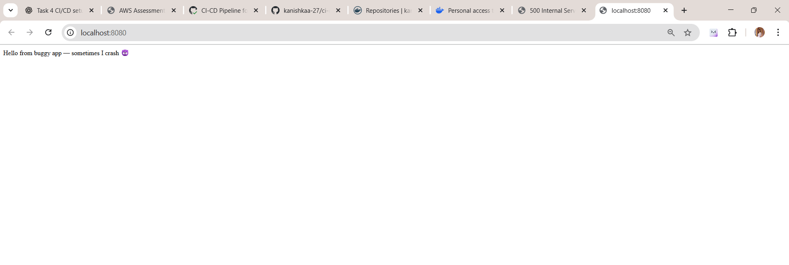

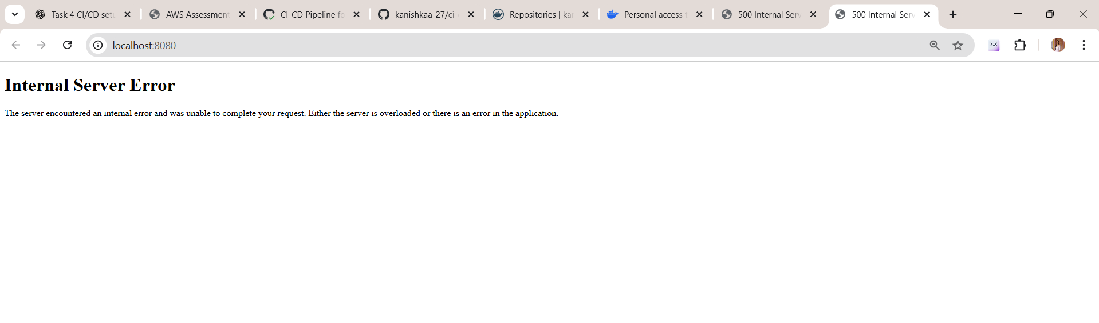
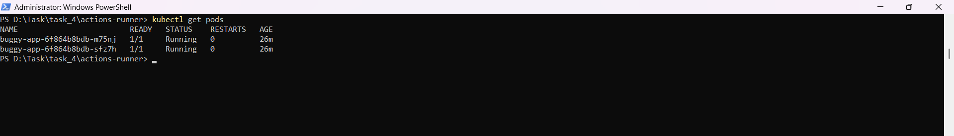

Logs:

PS D:\Task\task_4\actions-runner> kubectl logs -l app=buggy-app --tail=50
127.0.0.1 - - [20/Nov/2025 04:57:12] "GET / HTTP/1.1" 200 -
127.0.0.1 - - [20/Nov/2025 04:57:12] "GET / HTTP/1.1" 200 -
127.0.0.1 - - [20/Nov/2025 04:57:12] "GET / HTTP/1.1" 200 -
127.0.0.1 - - [20/Nov/2025 04:57:13] "GET / HTTP/1.1" 200 -
127.0.0.1 - - [20/Nov/2025 04:57:13] "GET / HTTP/1.1" 200 -
[2025-11-20 04:57:13,851] ERROR in app: Exception on / [GET]
Traceback (most recent call last):
File "/usr/local/lib/python3.10/site-packages/flask/app.py", line 1455, in wsgi_app
response = self.full_dispatch_request()
File "/usr/local/lib/python3.10/site-packages/flask/app.py", line 869, in full_dispatch_request
rv = self.handle_user_exception(e)
File "/usr/local/lib/python3.10/site-packages/flask/app.py", line 867, in full_dispatch_request
rv = self.dispatch_request()
File "/usr/local/lib/python3.10/site-packages/flask/app.py", line 852, in dispatch_request
return self.ensure_sync(self.view_functions[rule.endpoint])(**view_args)
File "/app/app.py", line 19, in home
raise Exception("Random internal failure")
Exception: Random internal failure
127.0.0.1 - - [20/Nov/2025 04:57:13] "←[35m←[1mGET / HTTP/1.1←[0m" 500 -
[2025-11-20 04:57:15,447] ERROR in app: Exception on / [GET]
Traceback (most recent call last):
File "/usr/local/lib/python3.10/site-packages/flask/app.py", line 1455, in wsgi_app
response = self.full_dispatch_request()
File "/usr/local/lib/python3.10/site-packages/flask/app.py", line 869, in full_dispatch_request
rv = self.handle_user_exception(e)
File "/usr/local/lib/python3.10/site-packages/flask/app.py", line 867, in full_dispatch_request
rv = self.dispatch_request()
File "/usr/local/lib/python3.10/site-packages/flask/app.py", line 852, in dispatch_request
return self.ensure_sync(self.view_functions[rule.endpoint])(**view_args)
File "/app/app.py", line 15, in home
return 1 / 0 # division by zero crash
ZeroDivisionError: division by zero
127.0.0.1 - - [20/Nov/2025 04:57:15] "←[35m←[1mGET / HTTP/1.1←[0m" 500 -
[2025-11-20 04:57:15,815] ERROR in app: Exception on / [GET]
Traceback (most recent call last):
File "/usr/local/lib/python3.10/site-packages/flask/app.py", line 1455, in wsgi_app
response = self.full_dispatch_request()
File "/usr/local/lib/python3.10/site-packages/flask/app.py", line 869, in full_dispatch_request
rv = self.handle_user_exception(e)
File "/usr/local/lib/python3.10/site-packages/flask/app.py", line 867, in full_dispatch_request
rv = self.dispatch_request()
File "/usr/local/lib/python3.10/site-packages/flask/app.py", line 852, in dispatch_request
return self.ensure_sync(self.view_functions[rule.endpoint])(**view_args)
File "/app/app.py", line 19, in home
raise Exception("Random internal failure")
Exception: Random internal failure
PS D:\Task\task_4\actions-runner> for ($i=1; $i -le 50; $i++) {
>> try { Invoke-RestMethod http://localhost:8080 }
>> catch { Write-Host "FAILED" -ForegroundColor Red }
Hello from buggy app — sometimes I crash 😈
Hello from buggy app — sometimes I crash 😈
Hello from buggy app — sometimes I crash 😈
FAILED
Hello from buggy app — sometimes I crash 😈
Hello from buggy app — sometimes I crash 😈
Hello from buggy app — sometimes I crash 😈

